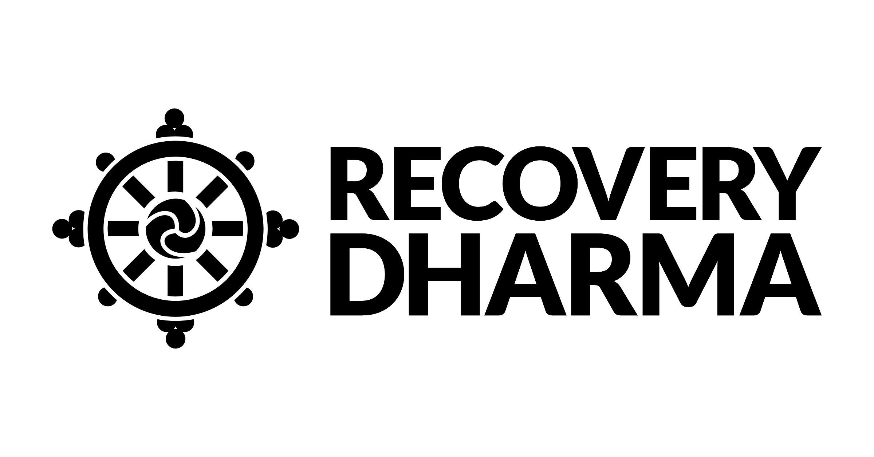

Recovery Dharma is a peer-led movement and community that is unified by our trust in the potential of each of us to recover and find freedom from the suffering of addiction. We believe that recovery means **empowerment**, and we support each other as partners walking the path of recovery together. Our program uses the Buddhist practices and principles of meditation, self-inquiry, wisdom, compassion, and community as tools for recovery and healing. Recovery Dharma welcomes anyone who is looking to heal from addiction and addictive behavior, whether it’s caused by substance use or process addictions like codependency, gambling, eating disorders, relationships, technology, or any obsessive or habitual pattern that creates suffering.

**Our meetings are open to anyone interested in recovery from addiction of all kinds. No meditation experience is necessary.**

|  |  |  |  |  |
| --- | --- | --- | --- | --- |
| The path of practice that we follow is based on the  FOUR NOBLE TRUTHS OF THE BUDDHA:   |  |  |  |  | | --- | --- | --- | --- | | There is  suffering | There is a cause of suffering | There is an end to suffering | There is a path that leads to the end of suffering | |

|  |
| --- |
| **For more information, visit: RecoveryDharma.Org** |

**Cleveland West Side Meetings:**

**Bear Soul Studio 15219 Madison Ave. Lakewood, Ohio**

**every Thursday @ 7:30**

**The River IOP 20033 Detroit Rd. #300 Rocky River,OH**

**every Tuesday @ 7:00 (beginning September 3rd)**